Temasek Polytechnic

School of Informatics and IT

**Diploma in Information Technology (IT)**

Software Test Specifications (STS)

**Project Particulars**

|  |  |
| --- | --- |
| **Tutor** | Mdm Ho Li Ching |
| **Class** | P02 |
| **Project Title** | Delonix Regia Hotel Management System |

**Project Team’s Particulars**

|  |  |
| --- | --- |
| **Matric Number** | **Student Name** |
| 1400555G | **Lin Jiamin** |
| 1403539H | **Chua Cheng Yu** |
| 1403575B | **Chloven Tan** |
| 1401557B | **Ngoh Man Ling** |

Revision History

|  |  |  |  |
| --- | --- | --- | --- |
| **Date** | **Version** | **Description** | **Author** |
| <dd/mm/yy> | <x.x> | <details> | <name> |
|  |  |  |  |
|  |  |  |  |
|  |  |  |  |

**Table of Contents**

1. DISTRIBUTION OF WORKLOAD

2. MODULE DEVELOPMENT AND UNIT TESTING

2.1 <Create Customize Report Module>

<Retrieve Customize Report Module>

3 SYSTEM INTEGATION

4 TEST LOG

# 

# 1. DISTRIBUTION OF WORKLOAD

# 

|  |  |
| --- | --- |
| Construction & Testing | Members |
| Create, Retrieve, Update, Delete for Customize Report Testing | Lin Jiamin |
| Create Customize Report Module, Retrieve Customize Report Module & Filtred Housekeeping Report Module | Lin Jiamin |
| View Housekeeping Report Function & CRUD Customize Report Scenario | Lin Jiamin |
| Viewing of Room Occupancy Report | Chua Cheng Yu |
| CRUD for Guest In Room Report | Chua Cheng Yu |
| CRUD for room booking module. | Chloven Tan |
| Homepage of the application | Chloven Tan |
| CRUD for employee record | Ngoh Man Ling |
| CRUD for employee schedule | Ngoh Man Ling |

# 

# 

# 

# 

# 2. MODULE DEVELOPMENT AND UNIT TESTING

## 2.1 <Create Customize Report Module>

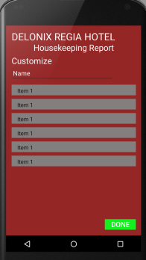

# 

# <Retrieve Customize Report Module>

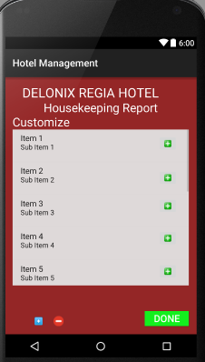

<Filtred Housekeeping Report Module >

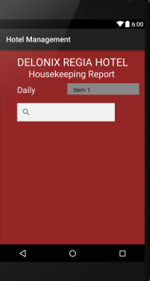

Cheng Yu

Firstly, I created the report home page showing 2 different reports. One is room occupancy report and the other one is guest in room report. For the room occupancy report, when it is being selected, it will bring us to the filter page where it can filter the check in date and will show us the room type, number of rooms occupied and number of rooms available. The other report is guest in room report. The guest in room also when selected, it will also bring us to the filter page to filter the room number and it will show the room number, number of adults and number of children. My team and I have to make sure that our codes do not have minor errors in it and also to use difficult codes that are easier to display our attributes rather than using longer and easier understanding of those codes. By that we can find errors easier and also to make our job easier when we are developing and testing our software at the same time. We followed using self-developed testing like the unit testing. Like to run our codes to access and read it and change it at the same time. This testing will make it easier to find out where is the errors and also to read which codes have been executed will running the software.

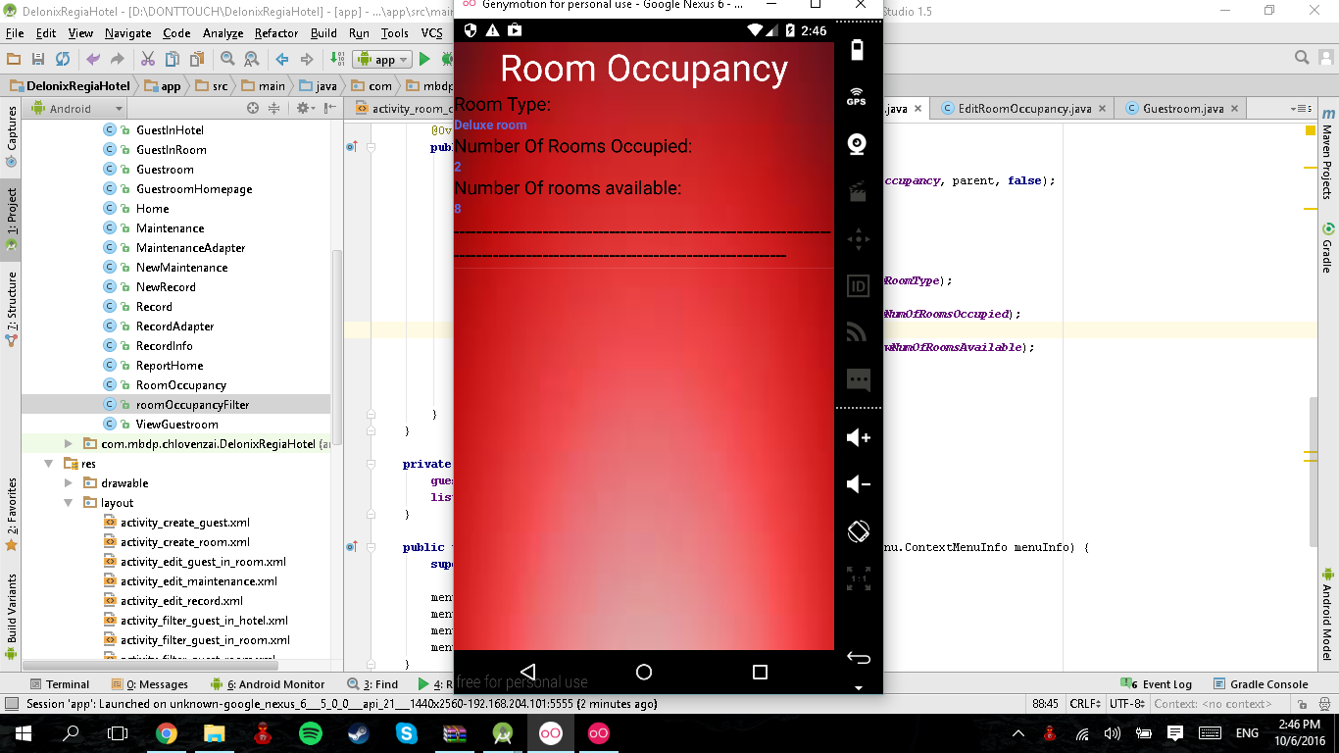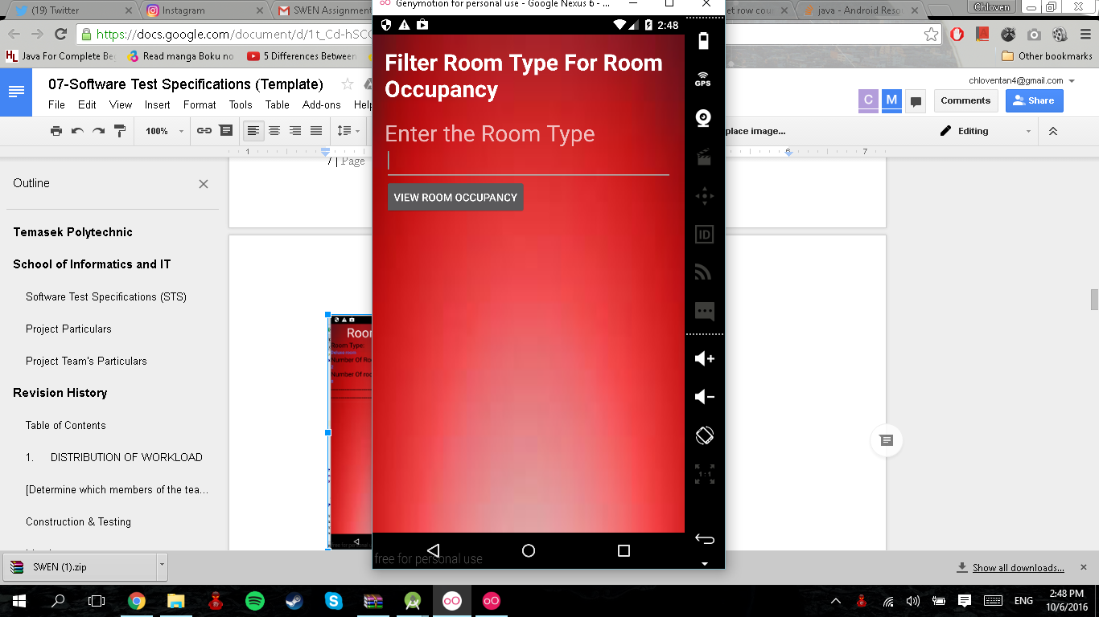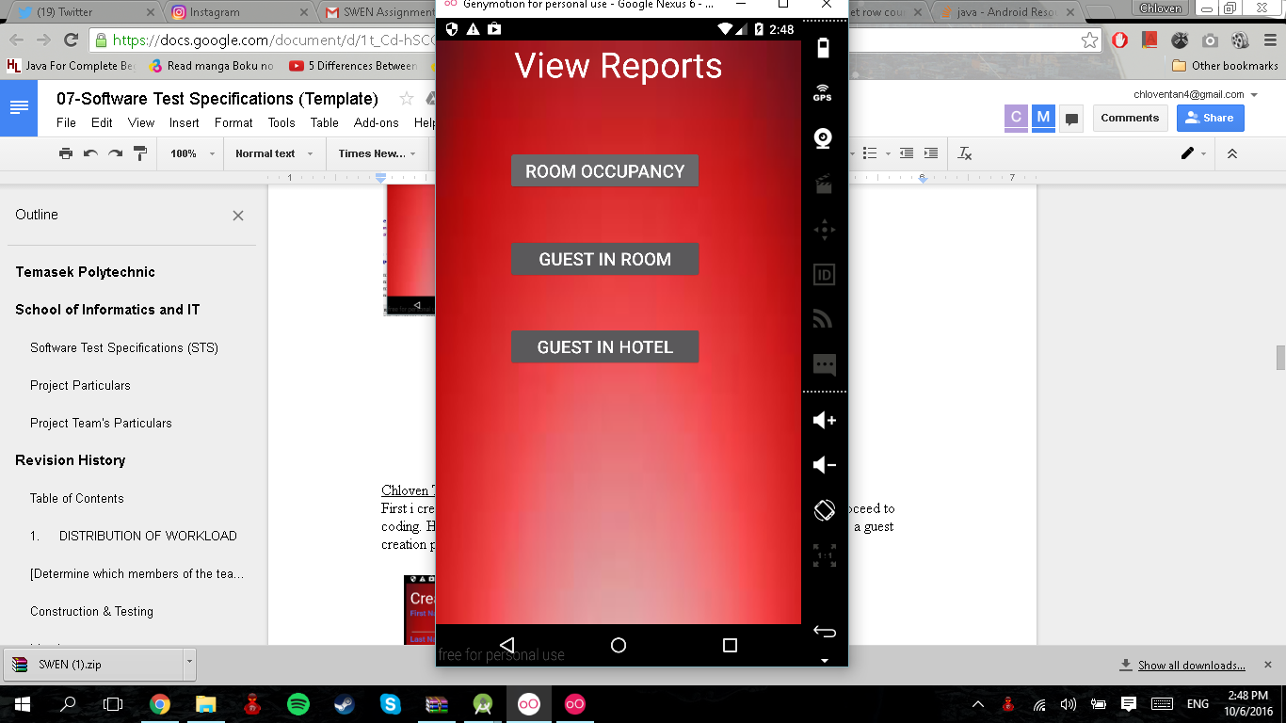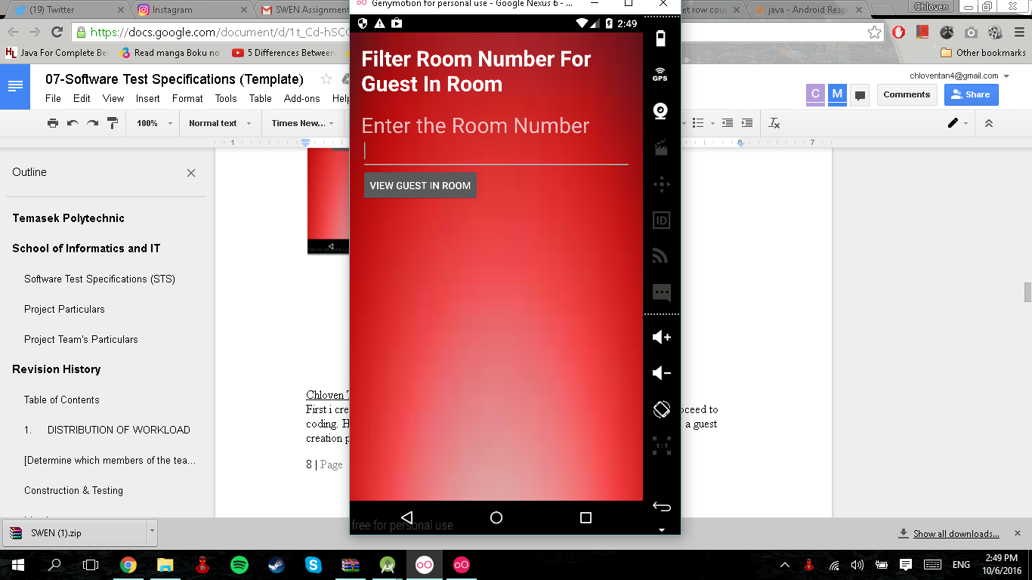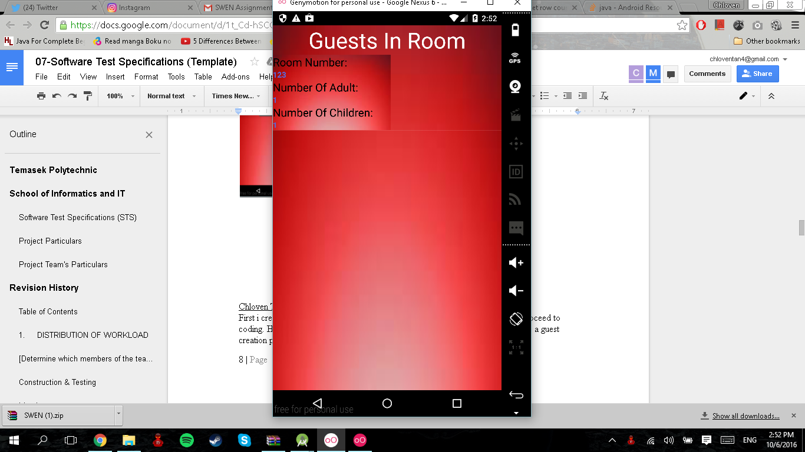

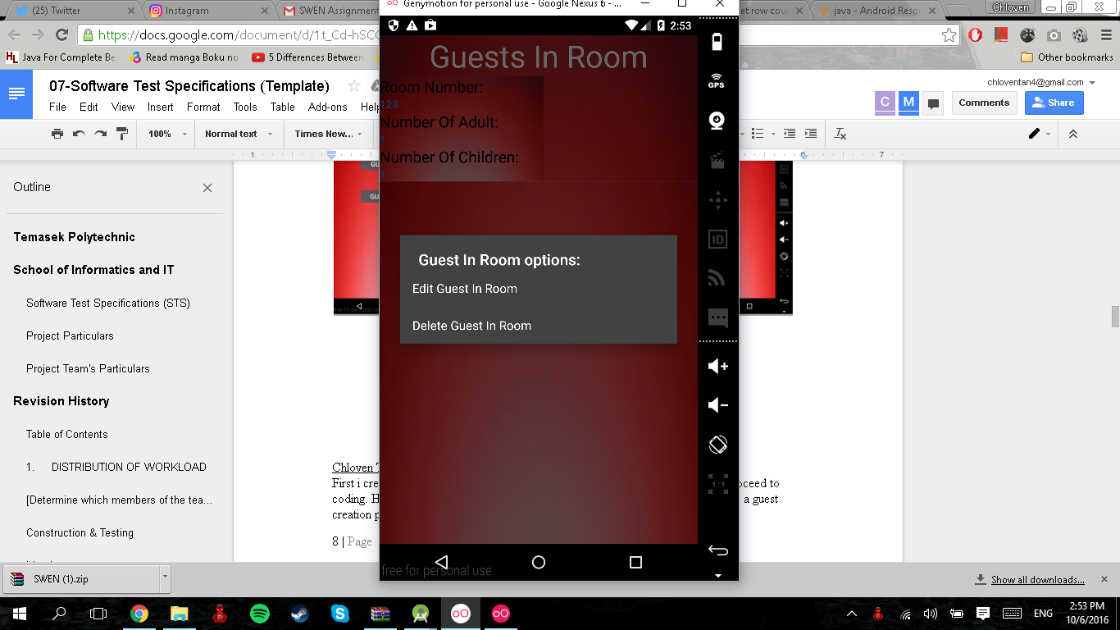

Chloven Tan

First, I create the design of the application to fit Mr. Wang’s requirement and then proceed to coding. Having too much data will be a problem in one page so I split the data’s into a guest creation page and a room creation page as shown below.

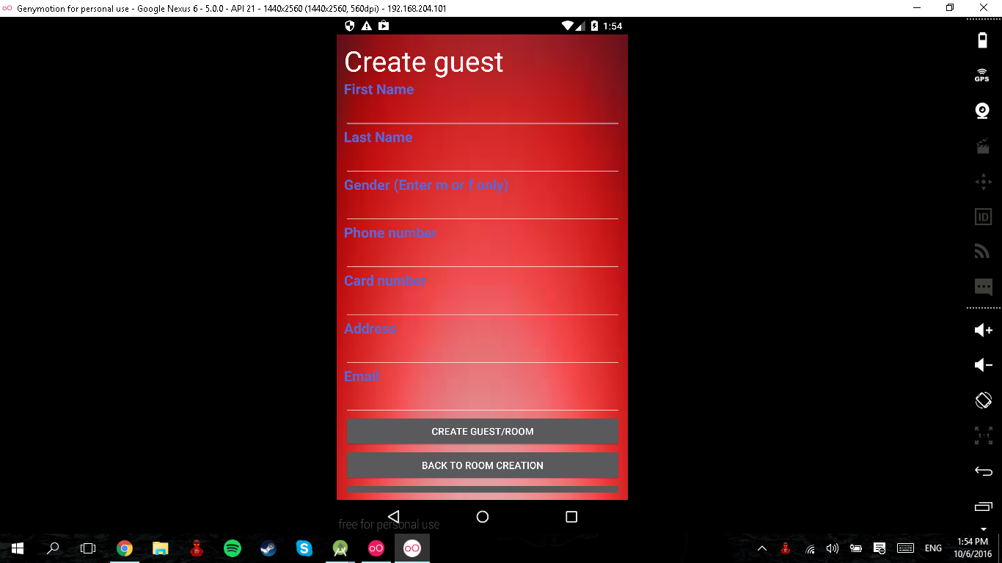

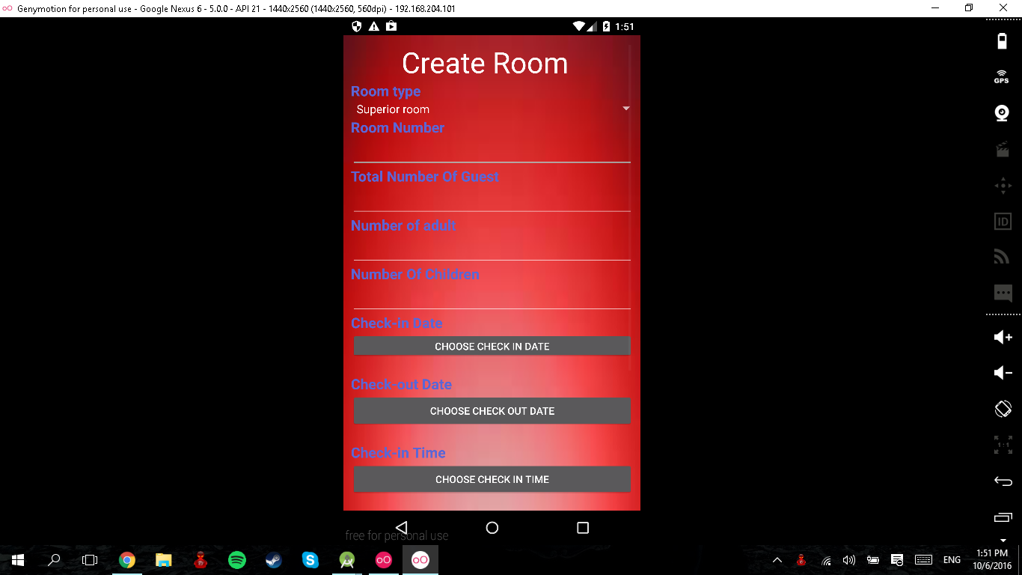

I have also validated the input and input types to prevent users from typing random characters. After creating and storing all the input data in the database, I proceed to listing all the data created to a listview. I also have created a filter to show only the data from the specific room type so as to allow the user to find the data to delete and edit conveniently if needed.

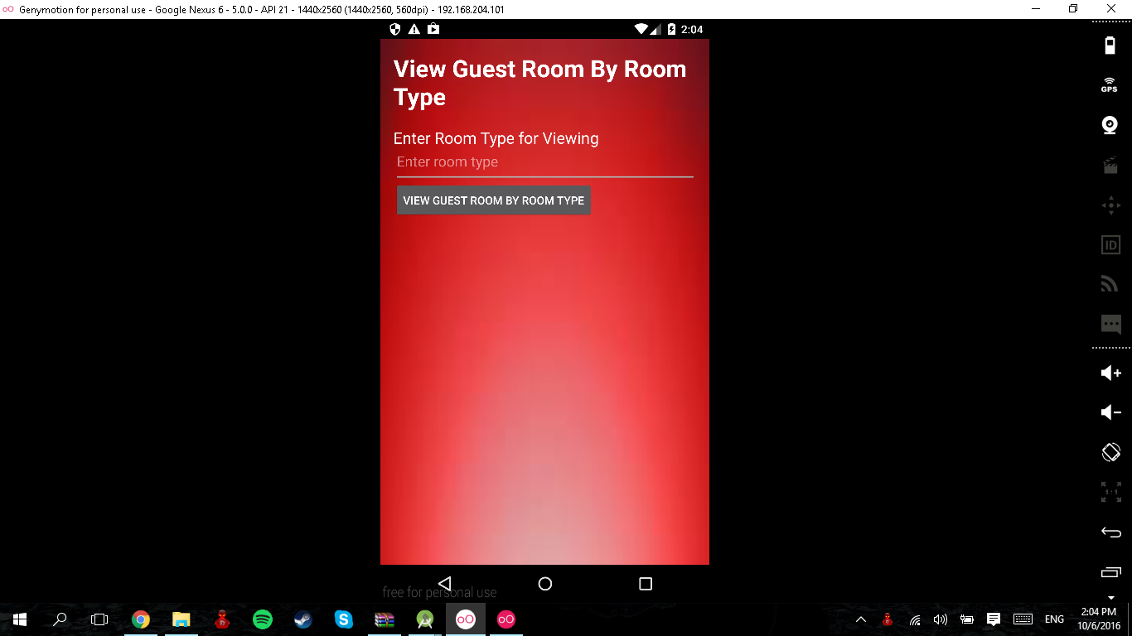

The list view is retrieved and is able to edit every data in the application and also deleting one guest and room just by holding on the data.

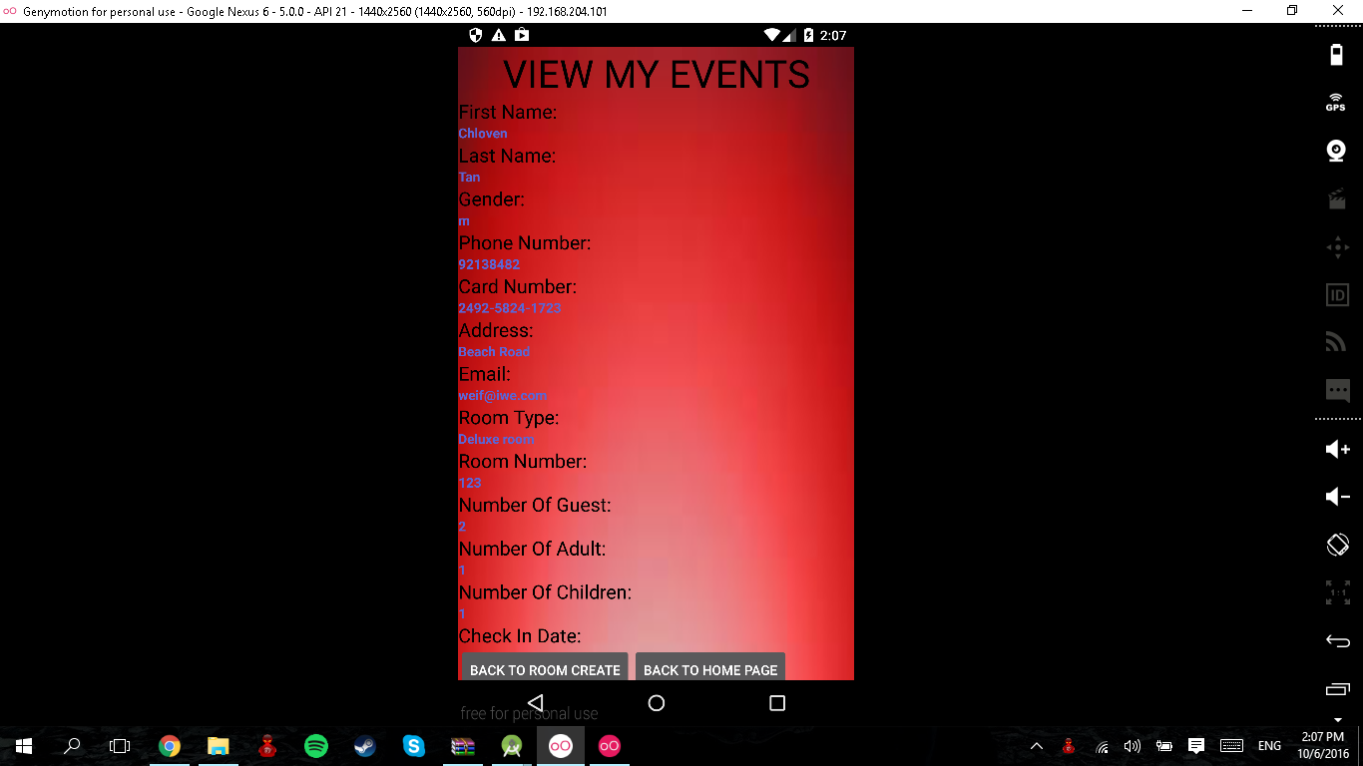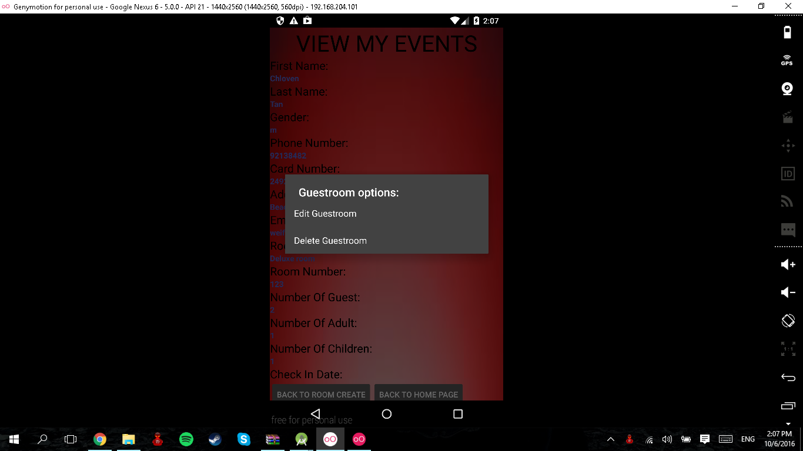

I test the project by trying to run the application every time I add a variable into the list view to find capture any data error that will occur like wrong names and data types will be revealed. I also test the project by running and changing the codes frequently like how i do it with the adding of data into the list view. i can easily spot errors and it is better to test while creating the codes.

Man Ling

I created the housekeeping page with two button on the first page which are employees’ record and schedule. The user will be able to create new items, retrieve saved items and delete item for both records and schedule. After creating new items when press add, items will be displayed in the list view. User can then choose to delete the items by clicking slightly longer on the item. An alert dialog will also pop up for the confirmation of deletion. I test every time I create a new function in a page. For instance, the new button in employees’ record page. After writing down the codes in android studio, i run the application to see if the button work. If it cannot work, I will edit the codes and run the application again. I also use the logcat in android studio to check the errors specified if there are any to resolve the issue.

# 

# 

# 3 SYSTEM INTEGATION

Cheng Yu

Since we are sharing the same database, we must ensure that we must have or share the same attributes in it. If we share the same attributes in the database, it will be easier for us to do the integration together and also at the same time to minimize the error in our software modules. If we have different attributes, we will still have to add additional attributes from other team members into the database and we might not know if the attributes in the database are overlapped with each other.

Chloven Tan

I ensure that we will be able to integrate during integration phase by creating the same database with the same attributes to for the database. Sharing database is essential as reporting module needs the data created from the room booking module in order for it to work.

I also try to link different modules in the application logically with the first page being the 3 buttons for 3 modules for the user to choose which shows that the application is integrated.

Man Ling

We will need to share database with each other so that all of us will be able to access the same database. The background of our application must also be the same for consistency. Each of us will then start to do on our own part. After ensuring that our part has no errors, we will compile our codes together. We will then try to run the application to see if it can run smoothly. We will also need to test the function of our own parts in the compiled application. This will allow us to resolve any errors before implementation of the application.

# 4 TEST LOG

JiaMin Part

## < CRUD Customize Report Scenario >

## 

|  |  |  |  |  |  |
| --- | --- | --- | --- | --- | --- |
| S/No | Steps | Test Data | Expected Results | Actual Results | Remarks |
| 1 | Select Customize Report OptionsAnd create Report | Room TypeFrequencyMonthYearDisplay TypeRoom Status | Report Save to View Customize class | Report save to my Database and display at View Customize class | Creating a database to save the Customize report |
| 2 | Edit the Customize Report | The Edit Button at the View List | Edit is done successfully and changes can be made. | The Editing button doesn’t work as the codes are different from the normal image button | Figuring out the codes to make the changes |
| 3 | Retrieve the Customize Report | The Data can be access at the View Customize class | when accessing file the Report is being updated | The file is saved and accessible | Retrieving was a success |
| 4 | Deleting the Customize Report | View List Reports | Report is deleted | Report is deleted | Deletion was a success |

## 

## 

## 

## 4.2 <View Housekeeping Report Function >

## 

|  |  |  |  |  |  |
| --- | --- | --- | --- | --- | --- |
| S/No | Steps | Test Data | Expected Results | Actual Results | Remarks |
| 1 | Fitter the Report search | Room Type | Report is filtered by the types of room user select | The View List display all the Room | Still Figuring how to link the filer to connect to the List View |
| 2 | To specify the the search results | Search Bar | Find the Specific results user want to search for | Results is displayed | Link from search bar to List View |

# 

Cheng Yu Part

<CRUD for Guest In Room Report>

|  |  |  |  |  |  |
| --- | --- | --- | --- | --- | --- |
| S/No | Steps | Test Data | Expected Results | Actual Results | Remarks |
| **1** | Select the guest in room report and filter the report by room number. | Room Number | Will be showing the room number and showing how many adults and children in it. | Results are displayed like showing the room number, number of adults and children. | Best to show this in daily weekly and monthly period. |
| 2 | Edit the guest in room report. | Room Number, Number of Childrens, Number of Adults | Being able to edit either one of them depends of the customer to change what. | Changes are being saved successfully in the database and shown on screen | To show the data in daily weekly monthly period. |
| 3 | Delete of the guest in room report. | Room Number, Number of Children, number of Adults. | Being able to delete the report successfully. | The report has being deleted successfully. | Being able to delete on either the number of children or adults individually. |

<Viewing of Room Occupancy Report>

|  |  |  |  |  |  |
| --- | --- | --- | --- | --- | --- |
| S/No | Steps | Test Data | Expected Results | Actual Results | Remarks |
| 1 | Select the room occupancy report and filter the report by room type. | Room Type, number of rooms occupied, number of rooms available. | When submitting the check in date, will be able to display the room type, number of rooms occupied, and number of rooms available. | Can displayed the room type, number of rooms occupied and number of rooms available. | Show it not only in daily but monthly and yearly too. |

Chloven Part

|  |  |  |  |  |  |
| --- | --- | --- | --- | --- | --- |
| **S/No** | **Steps** | **Test Data** | **Expected Results** | **Actual Results** | **Remarks** |
| **1** | Creating the guest and room details for booking | First name  Last name  Gender  Phone Number  Card Number  Address  Email  Room type  Room number  Num of guest  num of adult  num of children  check in date  check out date  check in time  check out time  additional remarks | To be created in the database. | Created in the database | Able to create into the database successfully. |
| **2** | Filtering the listview to retrieve data | Room Type | Retrieve only the data from the specific room types to the list view. | Listview retrieved data from the specific room type | Able to retrieve. |
| **3** | Edit and delete the data | First name  Last name  Gender  Phone Number  Card Number  Address  Email  Room type  Room number  Num of guest  num of adult  num of children  check in date  check out date  check in time  check out time  additional remarks | Able to edit each data from the list view and able to delete(checkout) the room and guest | Data from the listview are able to edit and delete successfully |  |
| **4** | Validating the data input for creation. | First name  Last name  Gender  Phone Number  Card Number  Address  Email  Room type  Room number  Num of guest  num of adult  num of children  check in date  check out date  check in time  check out time  additional remarks | Able to validate all forms that is left empty  and also able to validate input types like numbers and numbers and dashes (-) for the credit card | Only able to validate the Room creation for the fill in of blanks but able to validate all input types | Not sure on how to validate the guest inputs and put into the database at the same time. |

Man Ling

<CRUD on Employee records>

|  |  |  |  |  |  |
| --- | --- | --- | --- | --- | --- |
| **S/No** | **Steps** | **Test data** | **Expected Outcome** | **Actual Results** | **Remarks** |
| **1.** | Creating new employee records | Employee Name  Date of Birth  Address  Phone Number  Duty Type  Bank Number | Data will be save in the database.  Data will be display in the listview. | Data saved in the database.  Data display in the listview |  |
| **2.** | Updating of employee records | Employee Name  Date of Birth  Address  Phone Number  Duty Type  Bank Number | Data will be updated in the database.  Data will be updated in the listview. | Data are not updated to database. | Codes to update in the listview are written but not sure why it does not work. |
| **3.** | Deleting of employee records | Employee Name  Date of Birth  Address  Phone Number  Duty Type  Bank Number | Data will be deleted in the database.  Data remove from the listview. | Data deleted in the database.  Data remove from the listview. |  |
| **4.** | Retrieving of employee records | Employee Name  Date of Birth  Address  Phone Number  Duty Type  Bank Number | Saved records are display in the listview. | Saved records are display in the listview. |  |

<CRUD on Employee schedules>

|  |  |  |  |  |  |
| --- | --- | --- | --- | --- | --- |
| **S/No** | **Steps** | **Test data** | **Expected Outcome** | **Actual Results** | **Remarks** |
| **1.** | Creating new employee schedules | Name  Services  Date  Start Time  End Time | Data will be save in the database.  Data will be display in the listview. | Data saved in the database.  Data display in the listview | The services textfield refers to the employee’s department. Eg, Room, General, Estate, Security |
| **2.** | Updating of employee schedule | Name  Services  Date  Start Time  End Time | Data will be updated in the database.  Data will be updated in the listview. | Data are not updated to database. | Codes to update in the listview are written but not sure why it does not work. |
| **3.** | Deleting of employee schedules | Name  Services  Date  Start Time  End Time | Data will be deleted in the database.  Data remove from the listview. | Data deleted in the database.  Data remove from the listview. |  |
| **4.** | Retrieving of employee schedule | Name  Services  Date  Start Time  End Timer | Saved records are display in the listview. | Saved records are display in the listview. | Filtering of the saved records are yet to implement Eg. the date  . |